Assessing Analytic and Evaluative Skills Using Multiple Choice
AAPT “How We Teach” July 14, 2021
Jennifer Szende

Why use Multiple Choice in philosophy?

Effectiveness: MC testing can be an effective way of testing the learner’s ability to recall, understand, apply, analyze, and evaluate. (See, e.g. DiBattista 2008, 2011; Loftis 2019)

Fairness: Subjectivity of assessment is located at the stage of writing questions, rather than at the stage of marking questions. Subjectivity is more fairly distributed across all test takers (Loftis 2019)

Efficiency: Large scope of material in a relatively small/short test; easy to mark, even for large and online courses. Cognitive load of marking is reduced. Possibility of immediate feedback to learners. (DiBattista 2008, 2011)

Why do philosophers avoid multiple choice?

It’s too difficult for the instructor! Constructed answer questions are easier to produce (DiBattista and Kurzawa 2011).
- Practice writing questions in a variety of styles, for a range of skills.
- Pace yourself throughout the term.

MC is too easy/too low on Bloom’s taxonomy (DiBattista and Kurzawa 2011; Loftis 2019)
- *What is the purpose of the test?
- MC can be formative, medium to high on Bloom’s taxonomy, and can provide a valid measure of student achievement.
- Skills to test with MC: Recall; Understanding; Apply; Analyze; Evaluate? (Loftis)

Academic dishonesty. (McGee)
- *What is the purpose of the test? (Appropriate assessment strategies for the thing being tested).
- Use low stakes multiple choice testing.
- Use randomization.
- Consider using untimed test and/or open book tests. Design a test that will require looking up (some? Most?) answers, and give students time and permission to do so.
General best practices for Multiple Choice:
- https://uwaterloo.ca/centre-for-teaching-excellence/teaching-resources/teaching-tips/developing-assignments/assignment-design/designing-multiple-choice-questions
- Brame, C. (2013) Writing good multiple choice test questions. Retrieved [July 13, 2021] from https://cft.vanderbilt.edu/guides-sub-pages/writing-good-multiple-choice-test-questions/
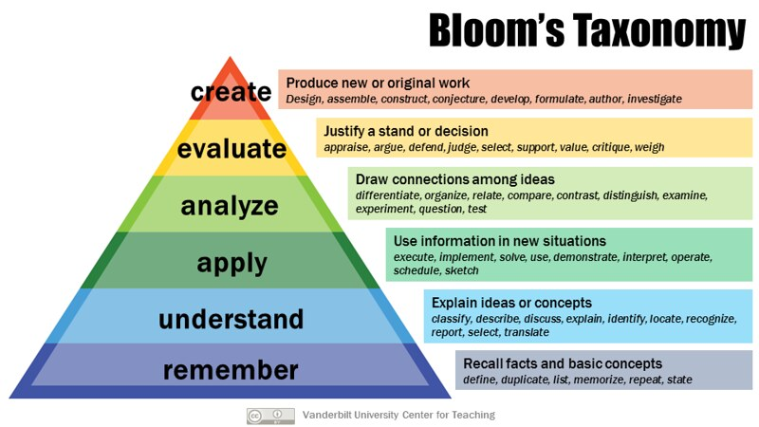

Some MC question writing strategies:
- Paraphrase:
  - Paraphrase the thesis.
  - Paraphrase key definitions.
  - Paraphrase key objections.
- Consider key terms and key concepts.
- Use comparisons/contrasts/lists drawn from course material.
- What does the example show?
  - Example from the reading: What point is Author making when they use X?
  - Example from the news/ film/ popular culture: What would Author say about X?
  - Example from the news/film/popular culture: Which Author would make which of the following claims?
- Who would agree with [paraphrase]?
- How might Author A respond to Author B’s question/quote/example/concern?
- Author A and Author B agree about X.
  - True or False?
  - Which reason would each give for X?

